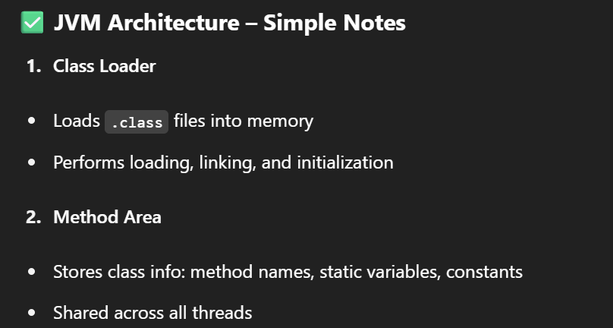

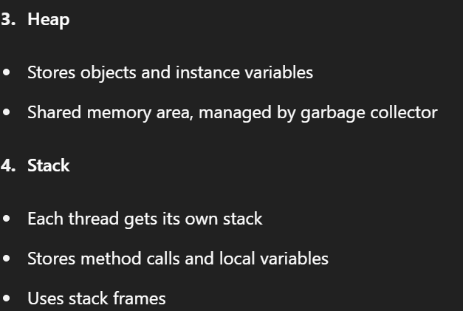

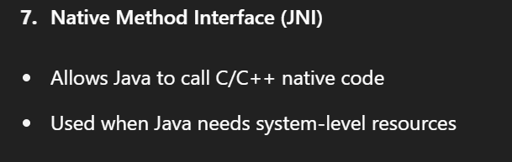

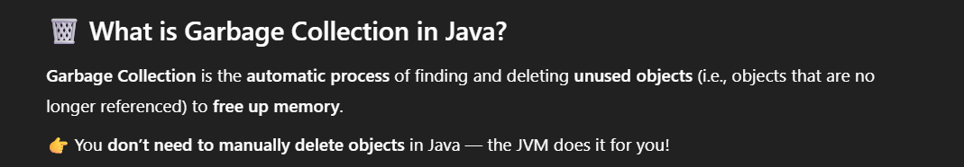

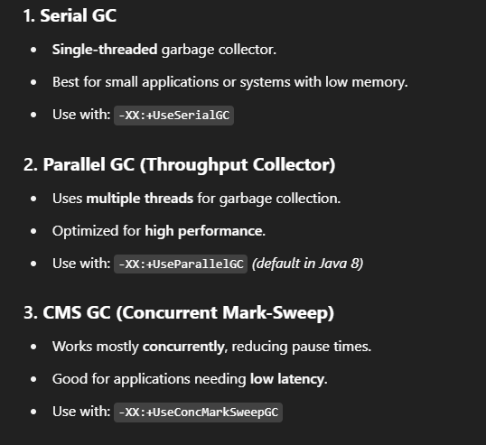

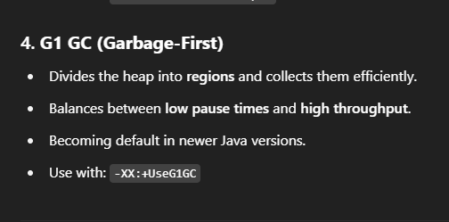

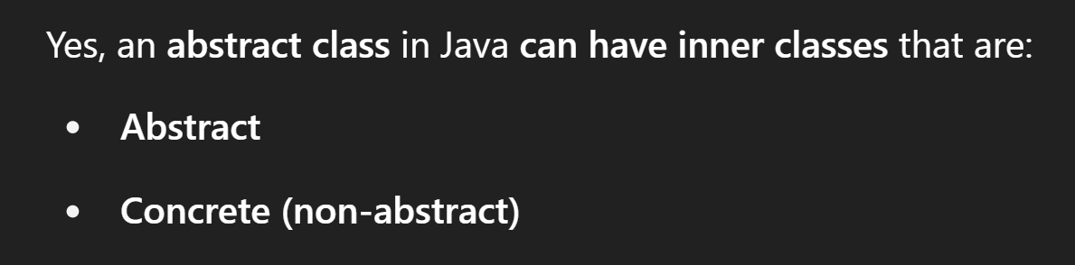

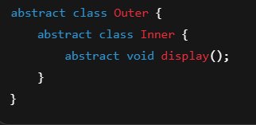

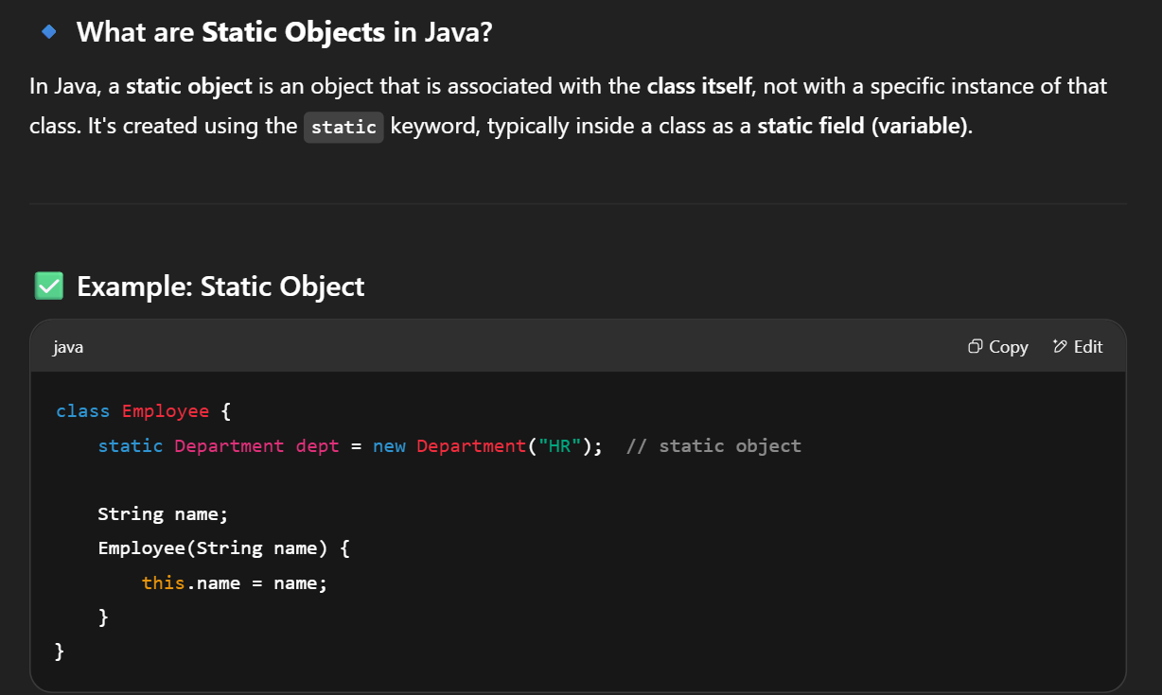

Static objects are helpful when you want a single shared instance that is available globally, without creating multiple objects.

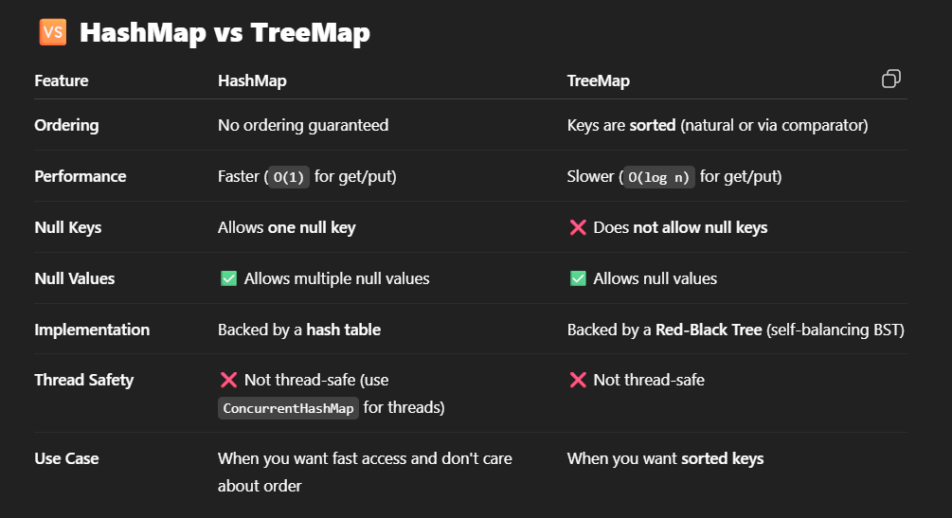

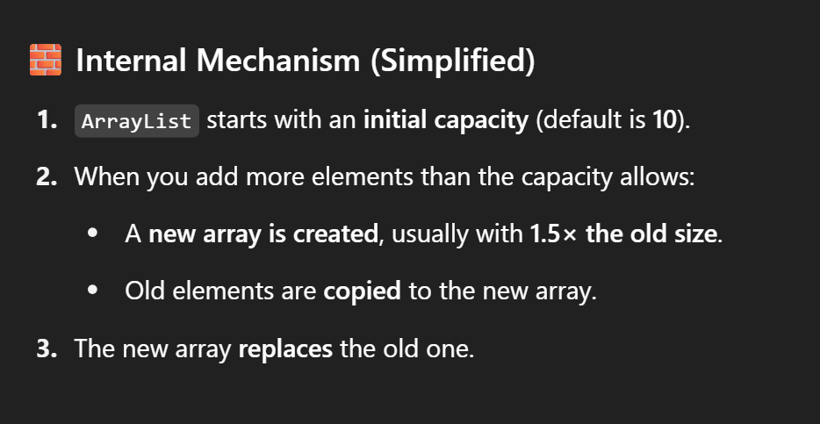

Arrays.copyOf

Use grow function

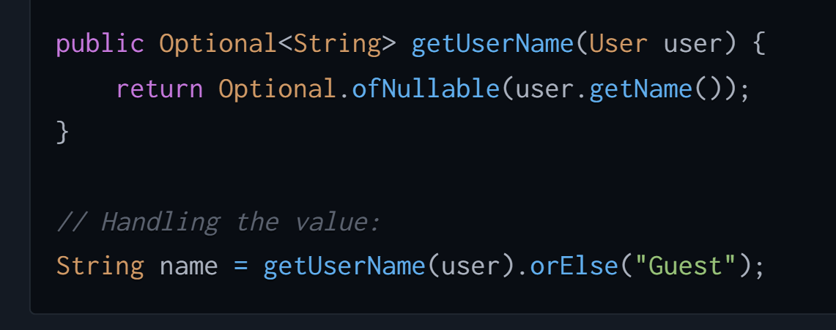

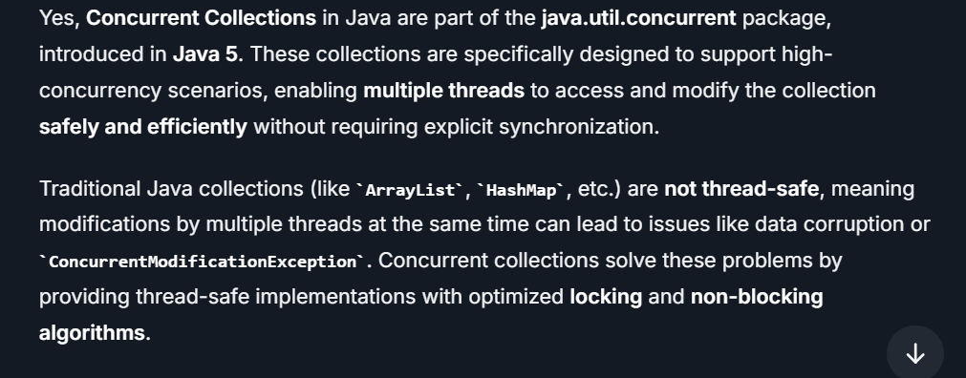

**ConcurrentHashMap**

**CopyOnWriteArrayList**

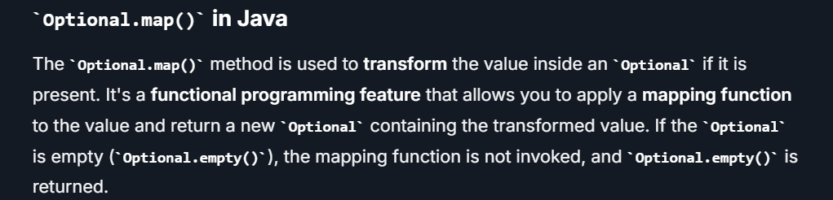

**What is JUnit?**

**JUnit** is a **Java-based unit testing framework** that is widely used to test individual units of an application, such as methods, classes, or small modules. It is part of the **xUnit** family of testing frameworks for various programming languages, and it allows developers to write and run automated tests for their code.

**TDD (Test-Driven Development)** is a **software development approach** where tests are written **before writing the actual code**. It is a part of **Agile methodologies** and emphasizes writing tests first, then developing the functionality to pass the tests, and finally refactoring the code.



